Install multiple swift storage nodes

The doc will introduce how to install multiple swift storage nodes according to packstack.

# packstack

## Install swift

If value（CONFIG_SWIFT_STORAGES） is omitted Packstack will create a loopback device for test setup. FileSystem type for storage nodes is etx4. Size of the swift loopback file storage device is 2G.

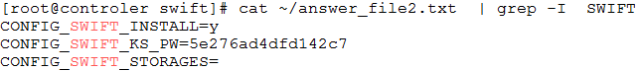

## Create a loopback device

/usr/share/openstack-puppet/modules/swift/manifests/storage/loopback.pp

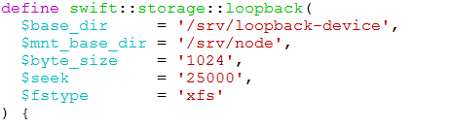

## Format the file

/usr/share/openstack-puppet/modules/swift/manifests/storage/ext4.pp

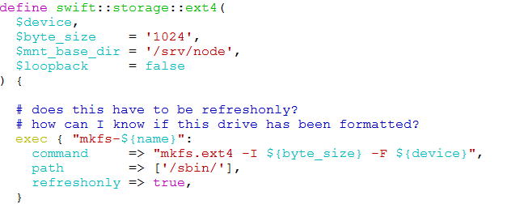

# Install multiple swift storage nodes

## Architecture



## Create a loopback decice and then mount on cinder back node

(1)mkdir -p /srv/loopback-device

(2)dd if=/dev/zero of=/srv/loopback-device/swiftloopback bs=1024k count=0 seek=2000

(3)mkdir -p /srv/node/

(4)mkfs.ext4 -I 1024 -F /srv/loopback-device/swiftloopback

(5)mkdir /srv/node/swiftloopback

(6)modify /etc/fstab

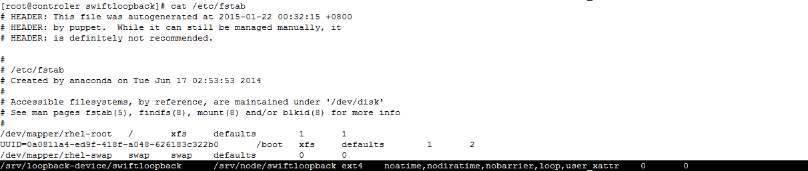

(6)mount /srv/node/swiftloopback

after mount,/dev/loopo has mounted to /src/node/swiftloopback

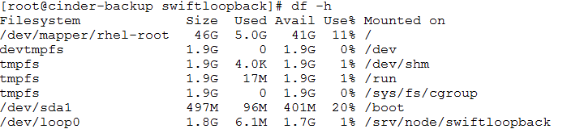

## Install packages and change configurate on cinder-backup node(cinder-backup node)

(1)install packages

yum install -y openstack-swift-account openstack-swift-container openstack-swift-object xfsprogs xinetd

(2)copy configure files from controller node

scp root@controler:/etc/swift/account-server.conf /etc/swift

scp root@controler:/etc/swift/container-server.conf /etc/swift

scp root@controler:/etc/swift/object-server.conf /etc/swift

scp root@controler:/etc/swift/swify.conf /etc/swift

(3)modify those configure files

openstack-config --set /etc/swift/account-server.conf DEFAULT bind_ip 10.228.254.151

openstack-config --set /etc/swift/container-server.conf DEFAULT bind_ip 10.228.254.151

openstack-config --set /etc/swift/object-server.conf DEFAULT bind_ip 10.228.254.151

openstack-config --set /etc/swift/account-server.conf DEFAULT devices /srv/node/

openstack-config --set /etc/swift/container-server.conf DEFAULT devices /srv/node/

openstack-config --set /etc/swift/object-server.conf DEFAULT devices /srv/node/

(4)modify /etc/rsyncd.conf(cinder-backup node)

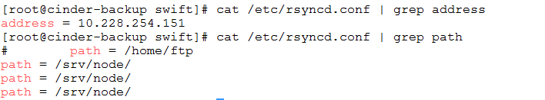

## Create ring files on controller node

How the packstack creates the ring files.( three replication )

/usr/share/openstack-puppet/modules/swift/manifests/ringbuilder/create.pp

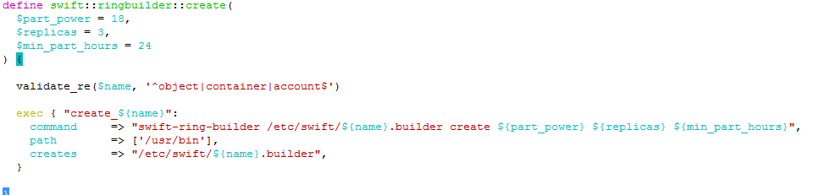

(1)delete ring config

swift-ring-builder /etc/swift/account.builder remove d10.228.254.143

swift-ring-builder /etc/swift/container.builder remove d10.228.254.143

swift-ring-builder /etc/swift/object.builder remove d10.228.254.143

(2)check ring config after delete

swift-ring-builder /etc/swift/account.builder

swift-ring-builder /etc/swift/container.builder

swift-ring-builder /etc/swift/object.builder

(3)create ring config

swift-ring-builder account.builder add z1-10.228.254.143:6002/swiftloopback 100

swift-ring-builder account.builder add z1-10.228.254.151:6002/swiftloopback 100

swift-ring-builder container.builder add z1-10.228.254.143:6001/swiftloopback 100

swift-ring-builder container.builder add z1-10.228.254.151:6001/swiftloopback 100

swift-ring-builder object.builder add z1-10.228.254.143:6000/swiftloopback 100

swift-ring-builder object.builder add z1-10.228.254.151:6000/swiftloopback 100

(4)check ring config after create

swift-ring-builder /etc/swift/account.builder

swift-ring-builder /etc/swift/container.builder

swift-ring-builder /etc/swift/object.builder

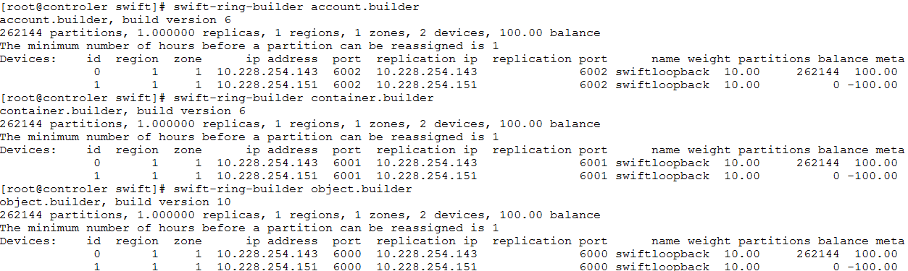

(5)rebalance ring config

swift-ring-builder account.builder rebalance

swift-ring-builder container.builder rebalance

swift-ring-builder object.builder rebalance

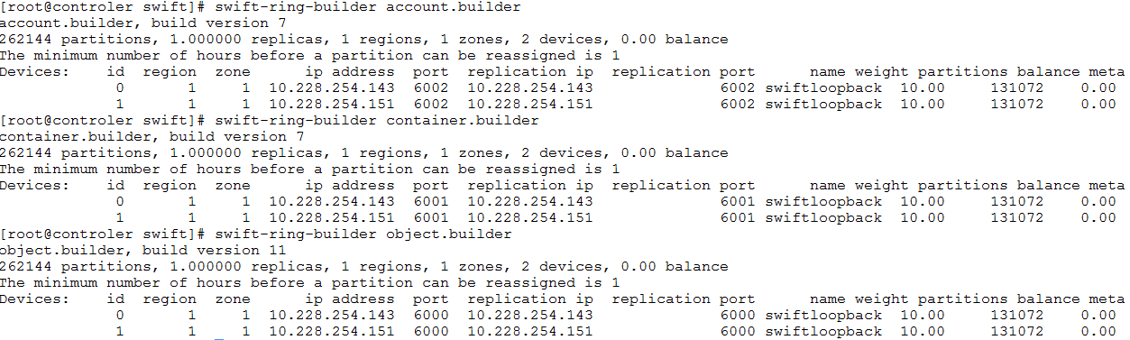

(6)copy ring fies to cinder-backup node

scp /etc/swift/*ring.gz root@10.228.254.151:/etc/swift/

## Modify file permission on cinder-backup node

groupadd swift

useradd swift -g swift

chown -R swift:swift /srv/node

chown -R swift:swift /etc/swift

mkdir -p /var/swift/recon

chown -R swift:swift /var/swift/recon

## Reboot services

### Controler node

systemctl restart openstack-swift-proxy

systemctl restart xinetd

systemctl restart openstack-swift-object

systemctl restart openstack-swift-object-replicator

systemctl restart openstack-swift-object-updater

systemctl restart openstack-swift-object-auditor

systemctl restart openstack-swift-container

systemctl restart openstack-swift-container-replicator

systemctl restart openstack-swift-container-updater

systemctl restart openstack-swift-container-auditor

systemctl restart openstack-swift-account

systemctl restart openstack-swift-account-replicator

systemctl restart openstack-swift-account-reaper

systemctl restart openstack-swift-account-auditor

### cinder-backup node

systemctl restart xinetd

systemctl restart openstack-swift-object

systemctl restart openstack-swift-object-replicator

systemctl restart openstack-swift-object-updater

systemctl restart openstack-swift-object-auditor

systemctl restart openstack-swift-container

systemctl restart openstack-swift-container-replicator

systemctl restart openstack-swift-container-updater

systemctl restart openstack-swift-container-auditor

systemctl restart openstack-swift-account

systemctl restart openstack-swift-account-replicator

systemctl restart openstack-swift-account-reaper

systemctl restart openstack-swift-account-auditor

chkconfig openstack-swift-object on

chkconfig openstack-swift-object-replicator on

chkconfig openstack-swift-object-updater on

chkconfig openstack-swift-object-auditor on

chkconfig openstack-swift-container on

chkconfig openstack-swift-container-replicator on

chkconfig openstack-swift-container-updater on

chkconfig openstack-swift-container-auditor on

chkconfig openstack-swift-account on

chkconfig openstack-swift-account-replicator on

chkconfig openstack-swift-account-reaper on

chkconfig openstack-swift-account-auditor on

chkconfig xinetd on

## Verify the two swift storage nodes

Add a container, and then add a file to this container

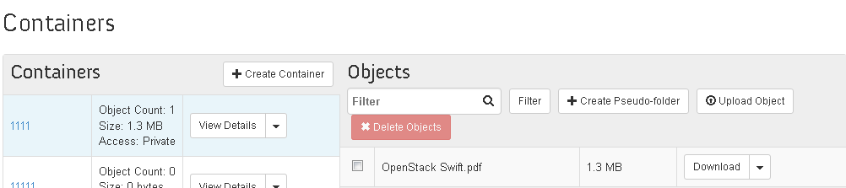

Check the swift storage

